 | COLLEGE OF ENGINEERING & TECHNOLOGY
 | Department  Course Title  Course Code  Date | : Computer Engineering  : : Introduction to Computers  : CC111  : fall 2012
Sheet (2)

Section One: Fill in the Blanks
- Images are stored in a computer using a coding scheme referred to as a ________________.
- _______________ is the name given to each point in an image.
- A computer program is represented in a computer using ________________ language.
- A language translator converts English-like high level programming languages into _________________ ____ so that the computer can understand them.
- A 2GB hard disk can store ____ bits.
- Video data is represented as a series of images called ________________.
- __________________ is the numbering system that represents all numbers using just two symbols (0,1).
- The ________________ is the chip located inside the system unit of the computer that performs the processing for a computer.
- The decimal value of the following binary number 1010 is ______.
- A(n) ______ is an electronic path over which data can travel
- A(n) ______ is a connector on the exterior of a computer than allows a peripheral device to be connected to the computer.
- A(n) _________________ is a special group of very fast memory chips located on or close to the CPU
- A(n) _______ and a(n) ________________ are two devices that can be used to cool down a CPU.
- All internal devices in a computer connect to a circuit board referred to as a ________________.
- A(n) _________ is a connector on the exterior of a computer than allows a peripheral device to be connected to the computer.
- RAM stands for _________________________.
- ROM stands for ______________________________.
- USB stands for ___________________________.
- PCIe stands for _____________________________________________.
- The four stages of a machine cycle are ___________, __________, ___________ and ___________.

Section Two: Choose the right answer/s

- ______ is a text coding scheme that uses 32 bits to represent each character.
  - ASCII
  - Binary
  - EBCDIC
  - Unicode

- The part of the CPU that performs logical and integer arithmetic is the ______.
  - ALU
  - Decode unit
  - PreFetch unit
  - Control unit
- As CPUs become smaller and smaller, the main problem becomes.
  - Developing technologies to connect these small components to the motherboard
  - Heating increasing
  - Accuracy decreases
  - Speed decreases
- The main purpose of the MP3 encoding scheme is to.
  - Improve the quality of music
  - Prevent you from illegally copying music
  - Reduce the size of music files
- The process of interleaving the different stages of a machine cycle in order to increase the throughput of a computer is referred to as.
  - Multiprocessing
  - Parallel processing
  - Multitasking
  - Pipelining

Section Three: Mark the following as True or False (T/F)

- ACSII is a coding system used by computers to perform arithmetic operations.
- A bus is a path way consisting of many conductors over which bits can be transferred.
- Computers that process data with light are referred to as quantum computers.
- The purpose of cache memory is to increase the storage capacity of a hard disk..
- A bitmap is the encoding technique used to represent audio data on a computer.
- The only factor that affects the processing speed of a CPU is its clock speed.

Section Four: Miscellaneous
1. Match the following picture to its corresponding name from the following names
( expansion card - memory module -USB hub- CPU)
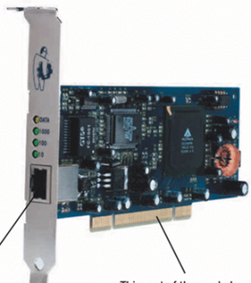
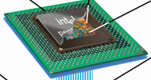
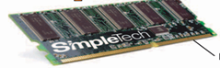
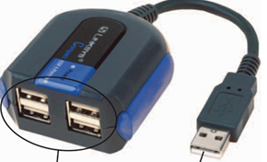

a. ____________ b. __________ c. ____________ d. _________

2. Match the terms in Column I to the definitions in Column II.
Column I | Column II | II | I
- Motherboard  - Web browser  - System bus  - Control unit  - Expansion buses  - Arithmetic logic unit (ALU)  - Bus  - Cache memory  - E-mail address  - Operating system  - Central processing unit (CPU)  - Domain name  - Port  - System unit  - Register | - An Internet address consisting of a username and computer domain name that uniquely identifies a person on the Internet.  - A type of system software that enables a computer to operate and manage its resources and activities.  - A program used to view Web pages.  - An electronic path on the motherboard or within the CPU along which data is transferred.  - The part of the CPU that coordinates its operations.  - A connector on the exterior of a PC's system unit to which a device may be attached.  - The main circuit board of a computer, located inside the system unit, to which all computer system components connect.  - The part of the CPU that performs logical operations and integer arithmetic  - A text-based Internet address used to uniquely identify a computer on the Internet.  - The bus that moves data back and forth between the CPU and memory | 1
 |  | 2
 |  | 3
 |  | 4
 |  | 5
 |  | 6
 |  | 7
 |  | 8
 |  | 9
 |  | 10

